The Royal College of Chiropractors
PRT Trainer Application Form 2022/23

Dear Prospective PRT Trainer,

PRT Trainer application

Thank you for your interest in becoming a PRT Trainer. Without trainers, the profession could not operate a scheme to support graduates through their transition from new graduate to fully autonomous and proficient practitioner. The Royal College of Chiropractors administers the PRT scheme to meet the needs of all chiropractic graduates.

Please refer to the PRT Handbook, available here, before completing the attached application form.

Please answer all the questions on the form. Note that a ‘Yes’ answer is not necessarily expected for every question but, collectively, your answers will allow the PRT Committee to determine the level of support you are able to offer to train a new graduate.

We look forward to receiving your completed form.

Yours faithfully

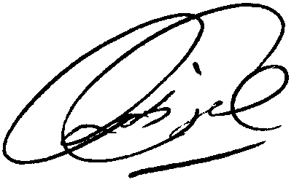

Rob Finch
Chief Executive

Section 1
Your name:
Your membership number or first line of practice address:
Your email address:
Name of graduate you propose to train:
The graduate’s practice address if not your own*:

*Note that in the current programme, the PRT Trainer need not work in the same practice as the graduate.

Section 2
 | - Please confirm how many years have you been practising as a chiropractor?
 | - How many years have you been working at your current practice?
 | - In addition to this, do you work from any other clinics? | Yes / No
 | - Do you conduct regular practice audits? | Yes / No
- When practising, will the graduate always be able to contact an experienced chiropractor? |  | Yes / No

How many hours per week of one-to-one contact time are you able provide?

How many hours per month would you be able to observe the graduate treating patients?

How many hours per month would the graduate be able to observe you treating patients?
Are you willing to participate in the RCC PRT Training the Trainers programme, which includes online learning and periodic participation in a Trainer’s forum? |  | Yes / No
- Have you arranged for a colleague to take on your responsibilities as Trainer, should you be absent for more than two consecutive weeks? |  | Yes / No
- Will you allow the graduate time for completion of the compulsory elements of the PRT scheme, including attendance at meetings? |  | Yes / No
- Will the graduate be taking on an existing patient list? |  | Yes / No
- How many patients will the graduate see per hour?
- How many patients per week do you expect the graduate to be seeing in the first month of their PRT year?
- How many patients per week do you expect the graduate to be seeing in the last month of their PRT year?

Declaration
I hereby apply to become a Royal College of Chiropractors PRT Trainer. I confirm that my answers to the above questions are true and complete.

Signature: | Date:

Please return your completed form to the PRT Administrator: admin@rcc-uk.org

